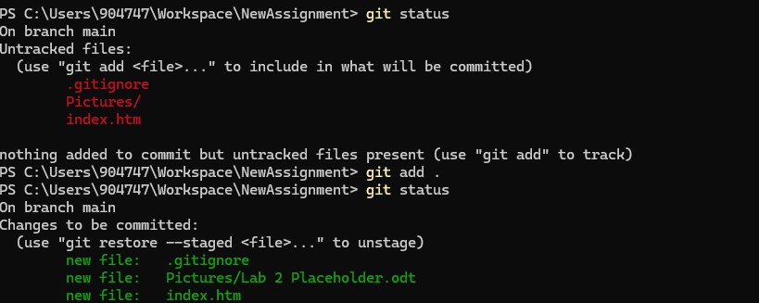
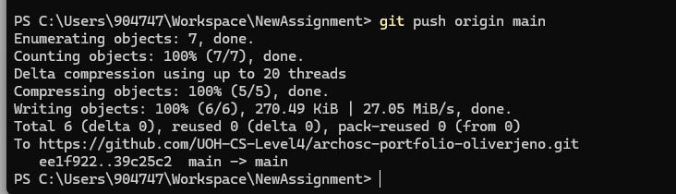
I created 2 folders pulled my GitHub work from last lecture into this lecture committed and pushed my work into the new GitHub repository

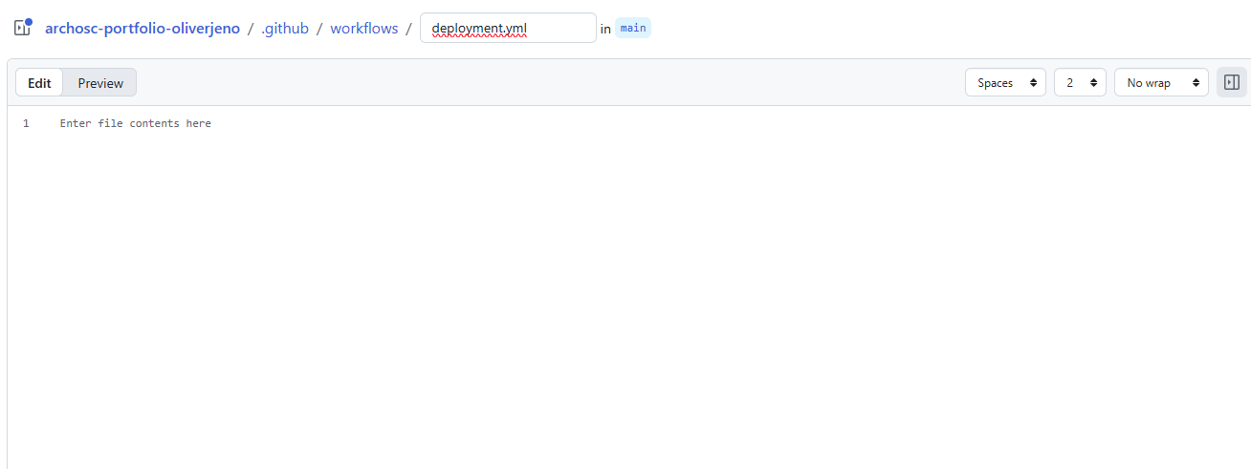

i went to my main page selected the actions button and then went to the github actions page selected “new workflow and added my own pipeline. Theni added the yaml page and changed it form main to deployment

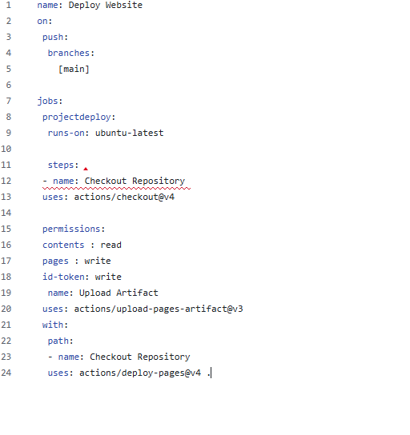

I then made this YAML to and this will be done each time with push to the main branch. “jobs” is then made to spin up my virtual machine and the steps section just groups it all together. U then gave the pipeline permissions (read and write) and then its pushed to the github pages. And lastly we want the last part of the code to tekk us that we want GitHub actions to choose a specific file or folder, and path: is the location of that file. I then deployed the code

